**Criterion B: Design**

An ideal solution to the problem with the current system would be to design and develop any database that holds all the information in one place for easier and more reliable data storage. My client had mentioned to be able to enter and manipulate data input and operate in a friendly user interface. The client also found it necessary to have a way of looking up information for each sale record.

Spread sheet Table

|  |  |  |  |  |  |  |  |
| --- | --- | --- | --- | --- | --- | --- | --- |
| DataSheet (This table stores the sales information input into the POS System User Form) | | | | | | | |
| Receipt No. | Customer Name | Customer Address | Customer Phone | Item Name | Quantity of Goods | Total Cost | Date of Purchase |
| ### | ABC | DEF | ######## | Silk Saree | ### | $$$ | dd/mm/yyyy |

|  |  |
| --- | --- |
| ReceiptSheet (This table records specific details required to generate the receipt) | |
| Receipt No. | ### |
| Sold To | ABC |
| Item | Silk Saree |
| Quantity | ### |
| Total Cost | $$$ |
| Date of Sale | dd/mm/yyyy |

|  |  |  |  |
| --- | --- | --- | --- |
| StockSheet (This table manages stock based on sales in the POS System User Form) | | | |
| Item No. | Item Name | Item Stock | Status |
| ### | ABC | ### | Available/Insufficient |

The database table above were the initial designs for the database that were finalised upon the several ideas discussed during the video conferences with the client. These 3 database tables were used to satisfy the requirements of the client and were developed in order to plan and understand where and how the data would be collected and stored.

The system architecture consists of the desktop PC, which uses VBA, to develop the user interface as well as the functionality of the application. Since VBA links the application to the Excel spread sheet, the application can directly interact with Excel database. The application uses these two components to handle instructions made by the client on the User Form, which will be relayed to the Excel database when necessary, thus making changes to the database which can be accessed later by the authorised employees.

Flowchart 1.1 **– Password System**

This flowchart represents the flow of how the password system functions to permit login.

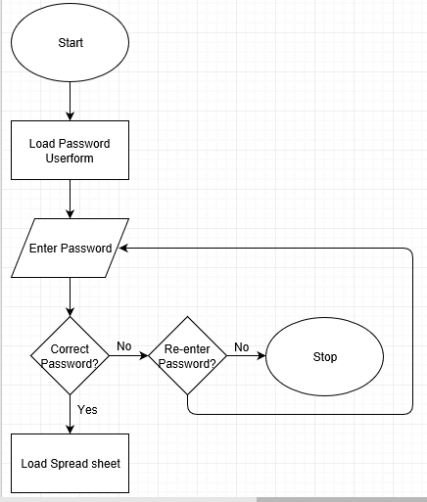

Flowchart 1.2 **– POS System**

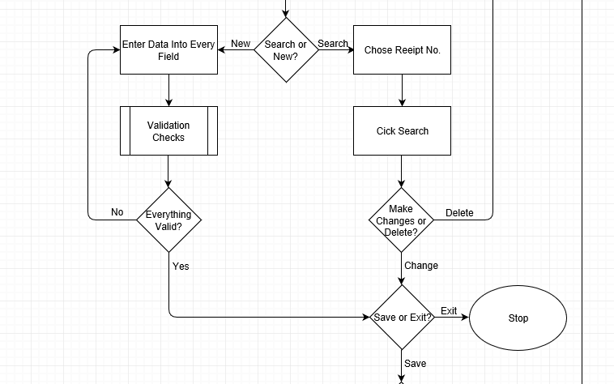This flowchart represents the flow of how the Point of Sale system functions to enable recording of sale information.

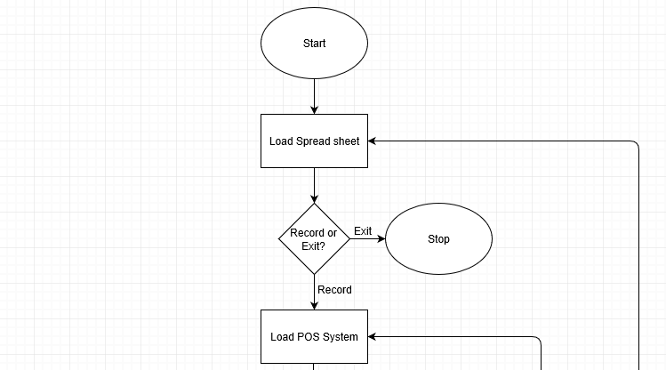

Flowchart 1.3 **– Receipt System**

This flowchart represents the flow of how the receipt system functions to allow printing of the sale receipt.

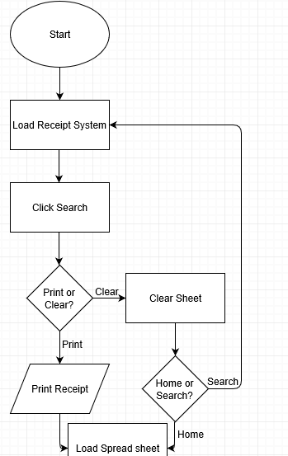

Flowchart 1.4 **– Stock System**

This flowchart represents the flow of how the password system functions to facilitate control of stocks.

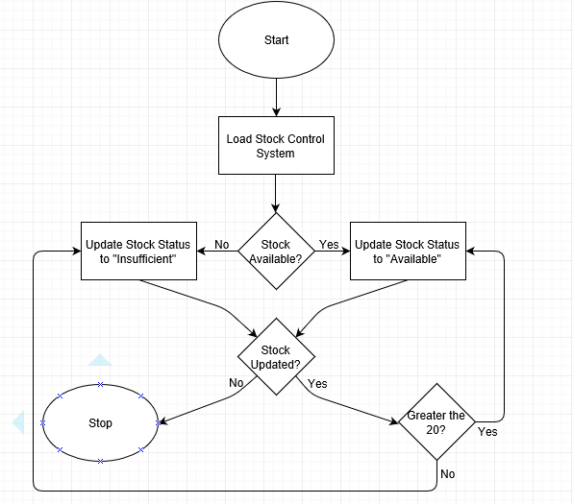

ERD Diagram – **Relation between Excel Spread sheets**

Receipt Sheet

Stock Sheet

1

1

1

1

Data Sheet

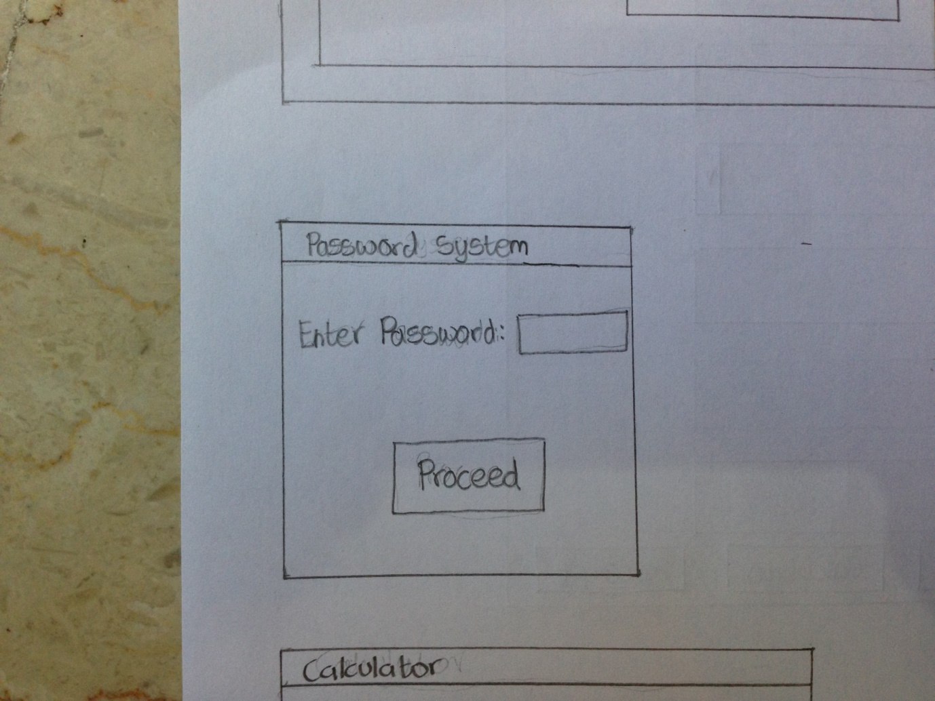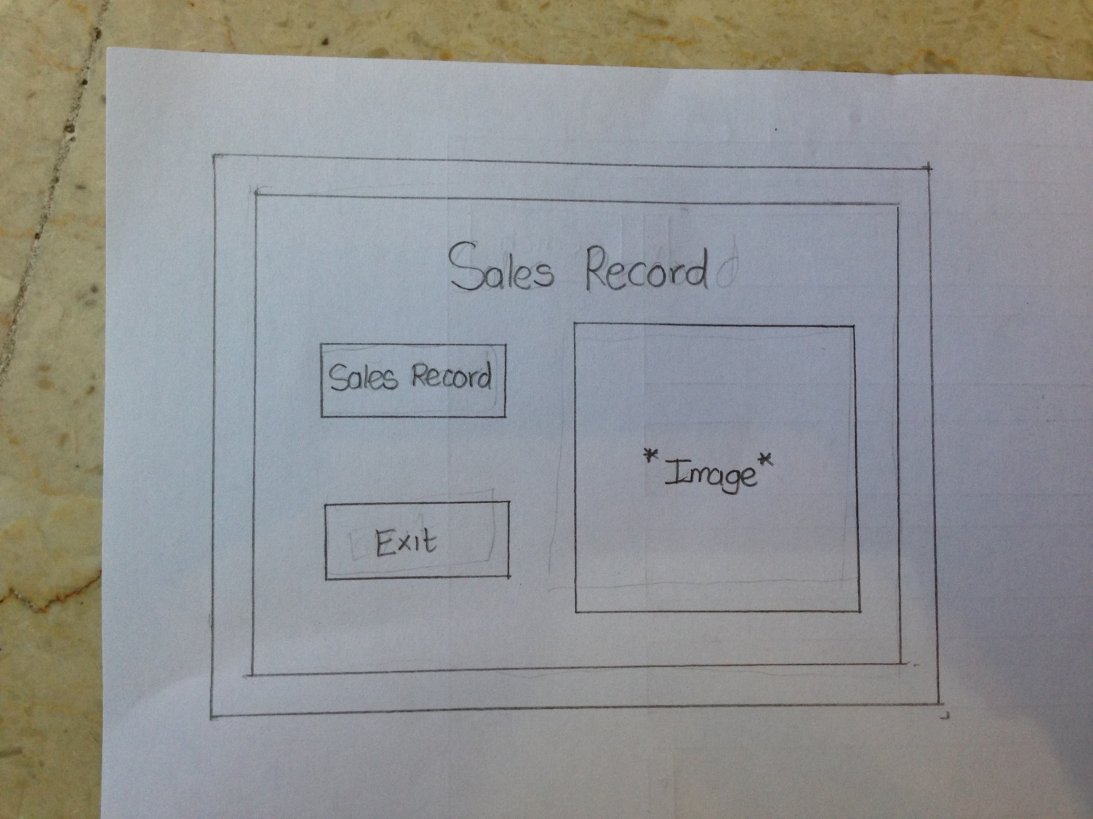Mock Designs – **Ratified by Client**[1]

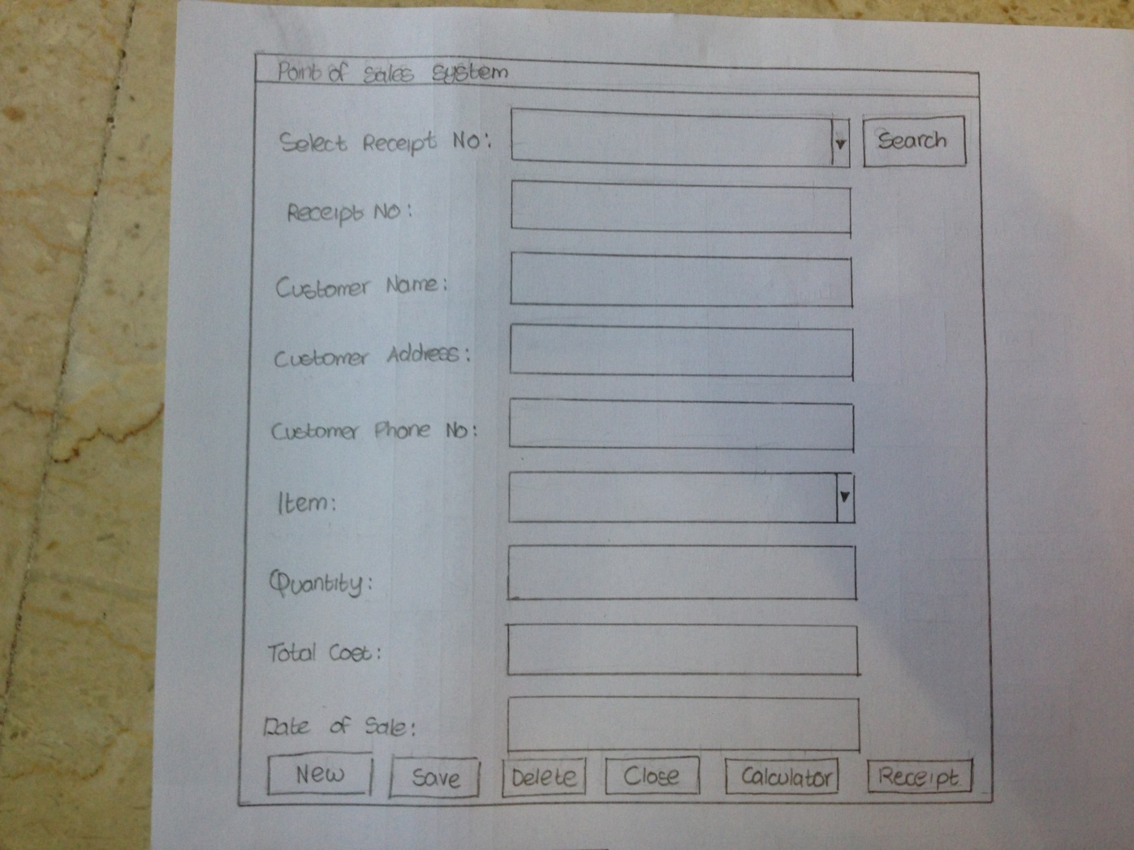

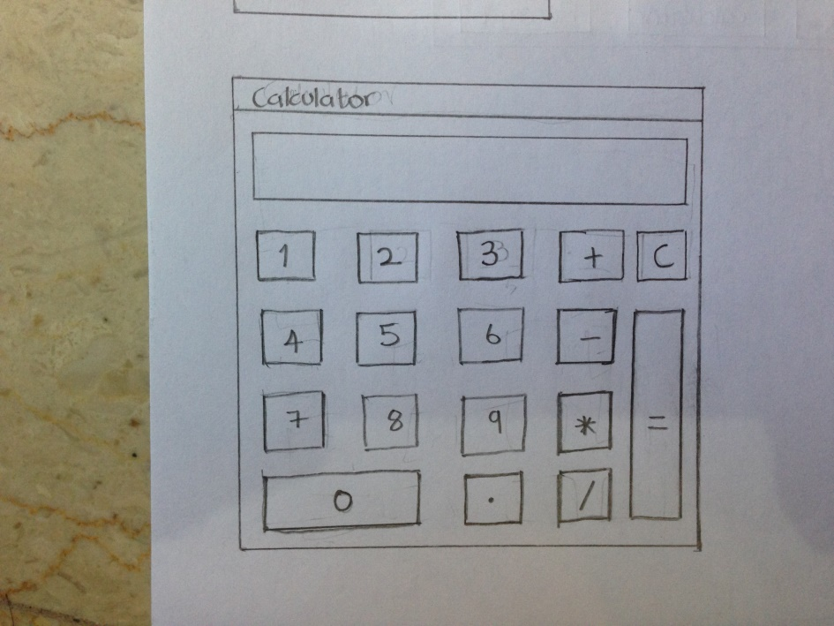

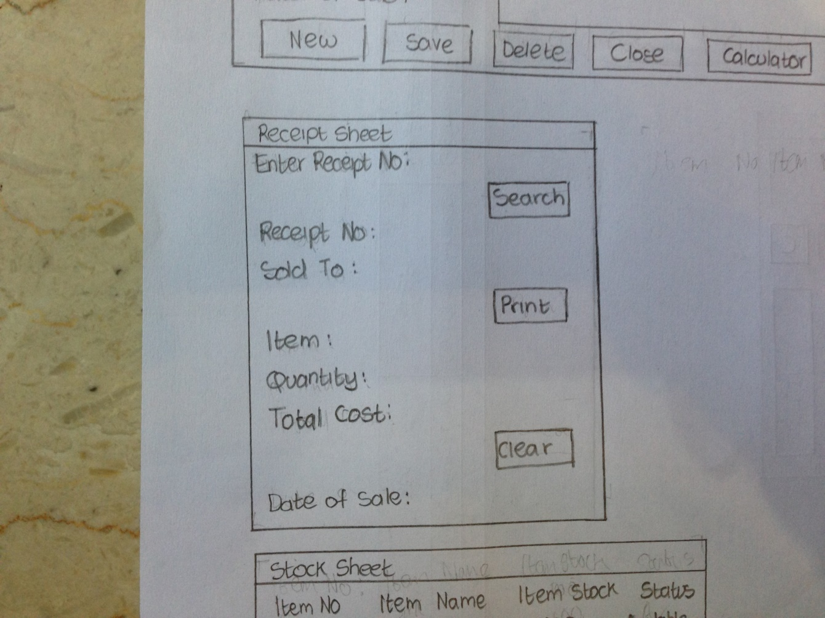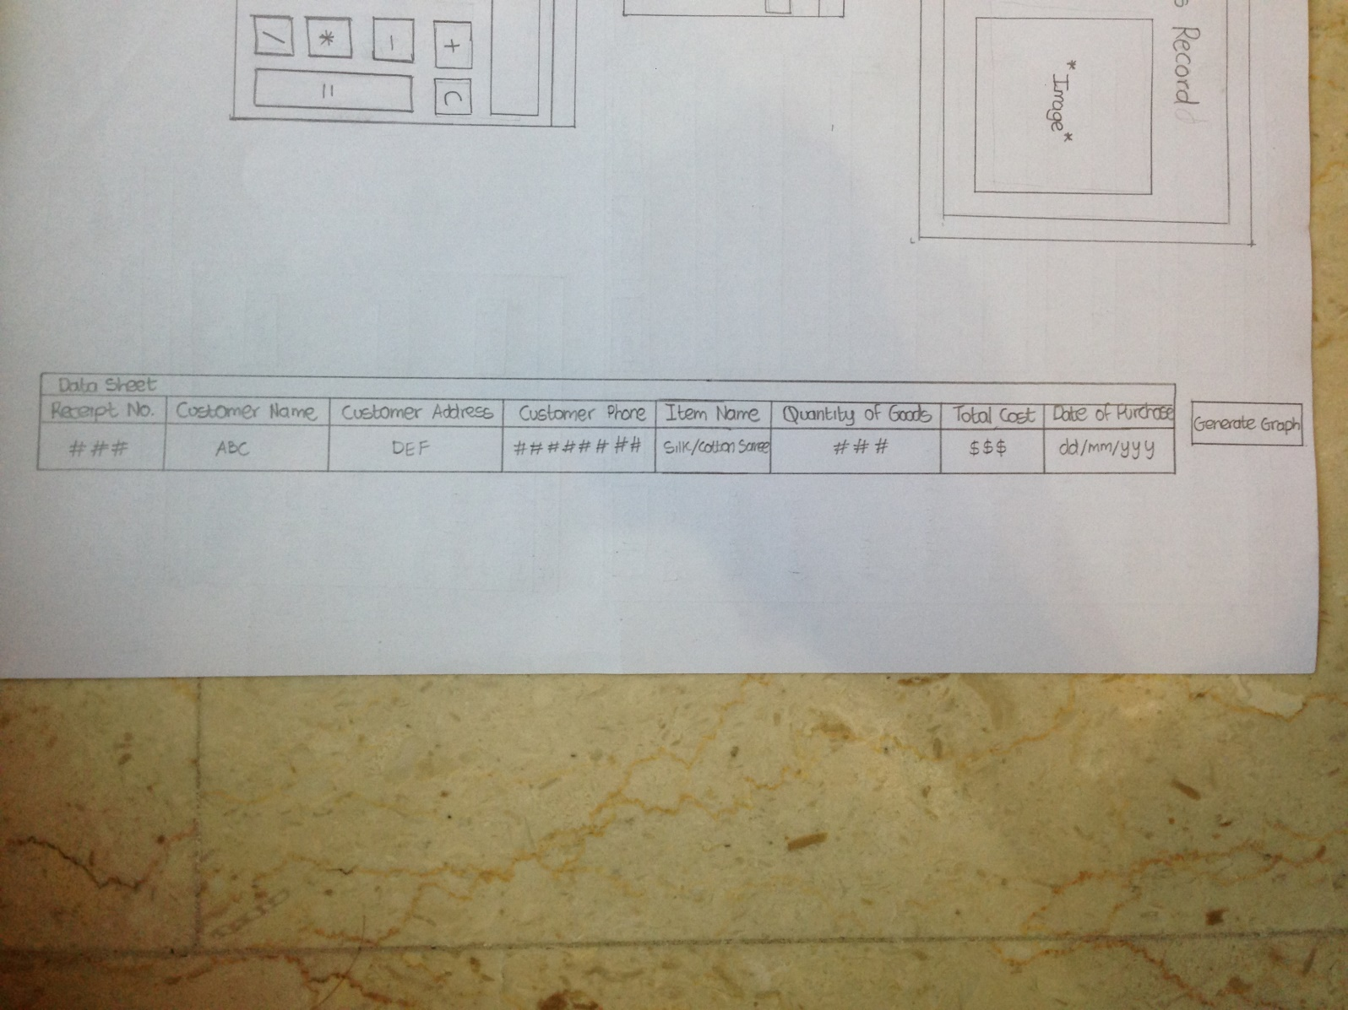

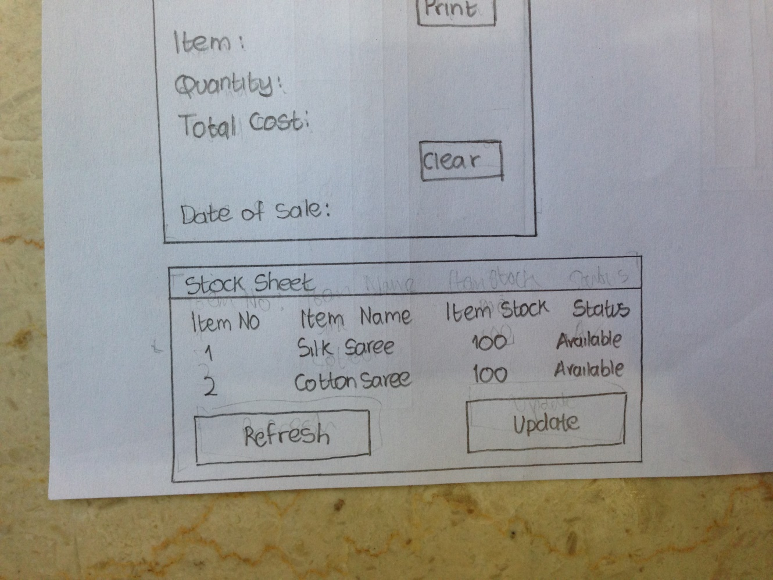

|  |  |  |  |  |  |
| --- | --- | --- | --- | --- | --- |
| Test No. | Module | Description | Steps | Expected Result | Actual Result |
| 1 | Login | Logging into the system. | -Open the software  -Input the password and click proceed | -Must prompt you to input password.  -If the password is correct, the user should be directed to the “Home” sheet in Excel. If not, a message saying “The password is incorrect. Do you wish to try again?” must be displayed. | -Password matched the pre-set password: Login is successful.  -Password doesn’t match with the pre-set password: Throw error, send user back to login dialogue box. |
| 2 | Add/Save | User can add various customer and sale records. | -Click “New”  -Input the details of each of the various input boxes.  -Click “Save”. | -Indicates the user to input the customer and sale details.  -Once the changes are made they must be saved onto the “Data” sheet in Excel. | -If value(s) falls within the validation rules: Data is saved.  -If value(s) falls beyond the validation rules: User is indicated to retype particular fields again. |
| 3 | Delete | User can delete various customer and sale records. | -Select Receipt No. from drop down menu and click “Search”.  -Click “Delete” once the values of the selected record are displayed in respective fields. | -Must clear out the records previously displayed in respective fields on the POS System User Form.  -Must delete record from the “Data” sheet in Excel. | NA |
| 4 | Edit | User can edit previously entered data. | -Select Receipt No. from drop down menu and click “Search”.  -Change the values to be corrected and click “Save”. | -Must update the field previously changed on the POS System User Form.  -Must update the respective record from the “Data” sheet in Excel. | NA |
| 5 | Calculator | User can do basic calculations. | -Enter the operator and operands.  -Click “=” symbol. | -Output must be the Addition, Subtraction, Multiplication or Division of the values entered. | NA |
| 6 | Receipt | Generate the receipt for particular records. | -Enter the Receipt No. on the “Receipt” sheet and click “Search”  -Once the required data has been retrieved click on “Print”.  -After printing click “Clear”. | -If “Search” is clicked and Receipt No. exists, the corresponding required field will be copied from the “Data” sheet and pasted on “Receipt” sheet. If not, a message saying “Receipt No. not found in Data” must be displayed. | -If the Receipt No. entered is existing: Required data is successfully retrieved.  -If the Receipt No. is not existing: Display error dialogue box. |
| 7 | Stock | -User can track the stock for various items and update the status of stock.  -User can also restock the items. | -Stock is updated any time a sale has been saved using the values Item Name and Quantity of Goods entered in the POS System User Form or any time an item is reorder using “Update” button in “Stock” sheet. | -With new records entered the stock for the corresponding item is updated.  -With items being reordered the stock for the corresponding item is updated. | -If the stock for a particular item is above 100: Status is Available.  - If the stock for a particular item is below 100: Status is Insufficient. |
| 8 | Graph | A graph for sales trends is generated. | -Click the “Generate Graph” button in the “Data” sheet. | -Redirects user to the “Graph” sheet and outputs a Table and a Graph of cost of sales and date of sale. | NA |

**Word Count: 314**

1. Refer to interview #1